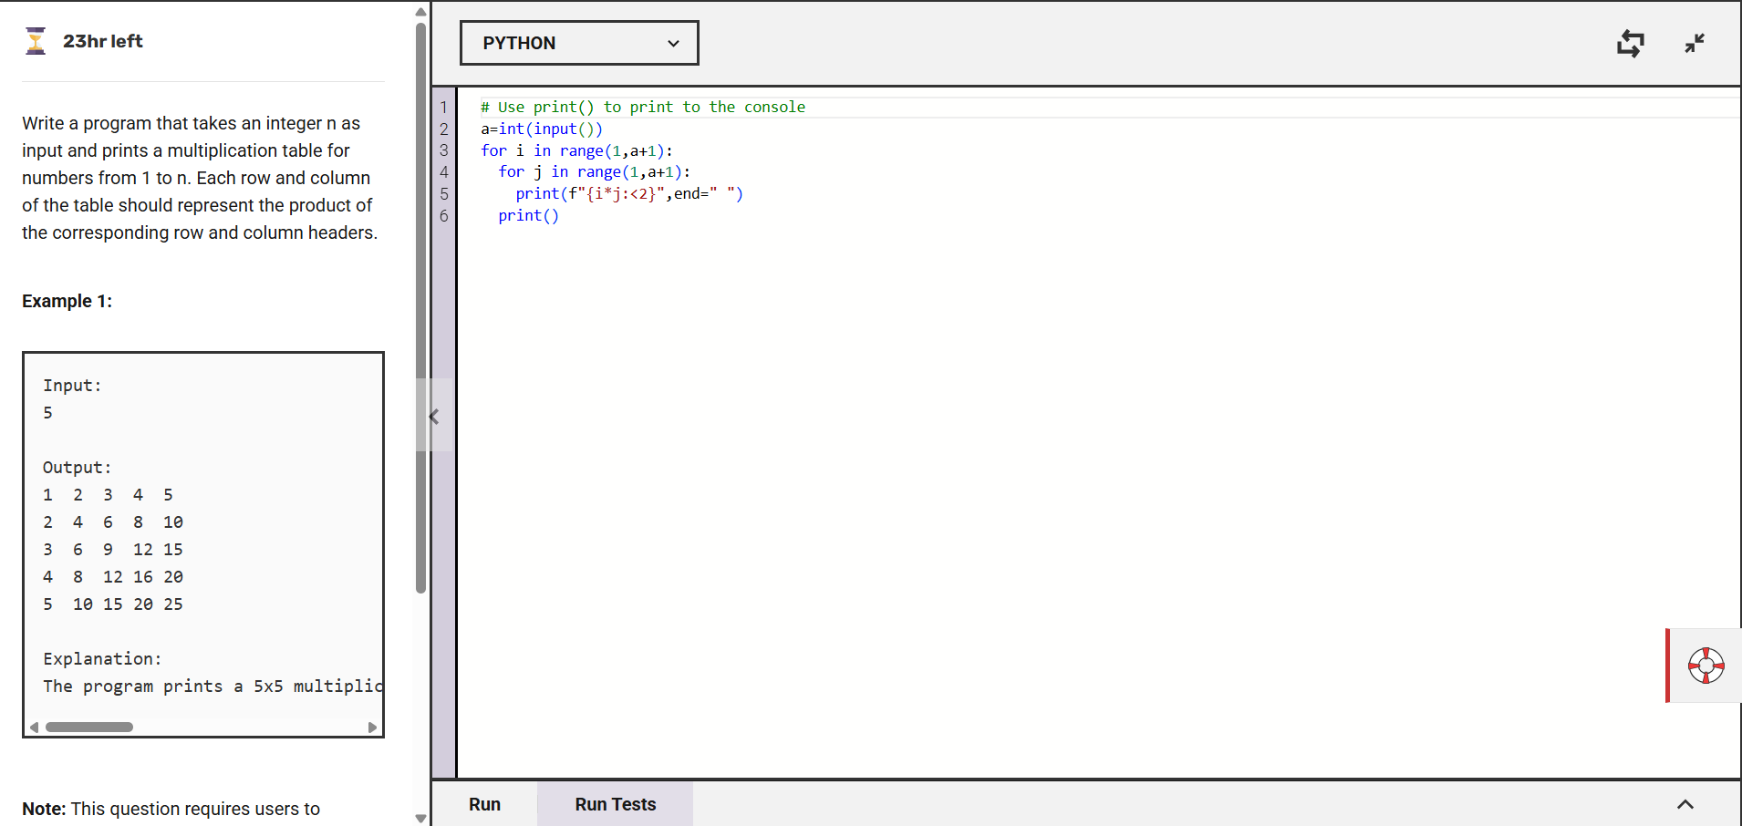

The code creates a multiplication table by looping through numbers from 1 to n and printing the product of row and column numbers .It uses nested loops: the outer loop for rows and the inner loop for column, printing each product in a grid format.

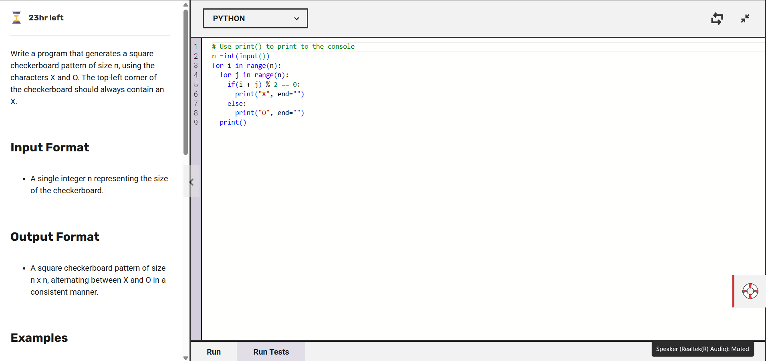

The code makes a chessboard pattern using 'X' and 'O', where each box changes its symbol like a real checkerboard. It does this by checking if the sum of row and column numbers is even (X) or odd (O).

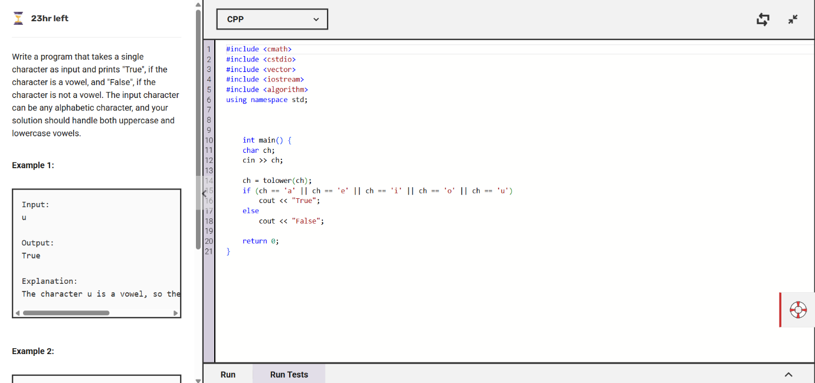

The program checks if a letter is a vowel (a, e, i, o, u) and prints True if it is, otherwise, it prints False. It also works for both uppercase and lowercase letters.

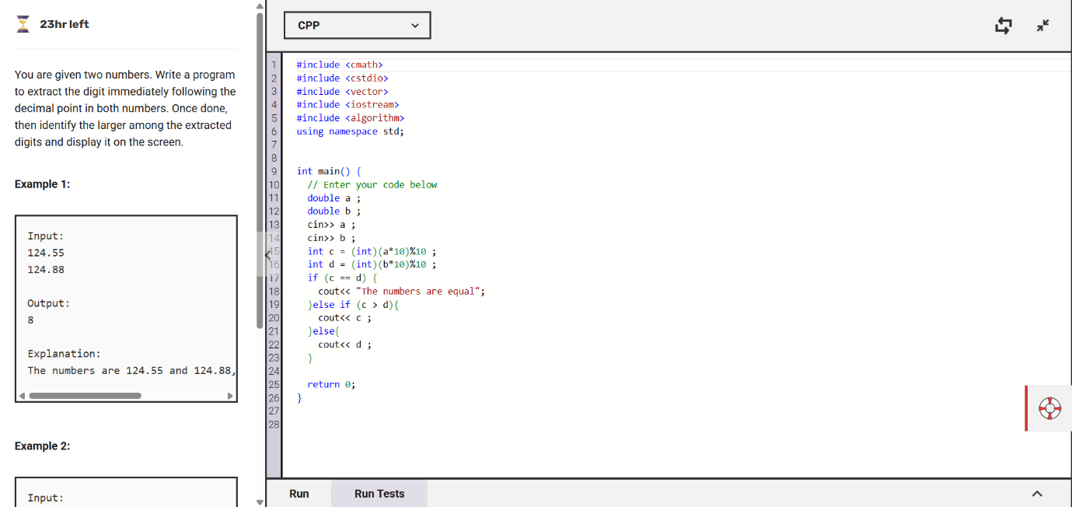

The program takes two numbers, picks the first digit after the decimal, and finds the bigger one. If both digits are the same, it prints The numbers are equal.

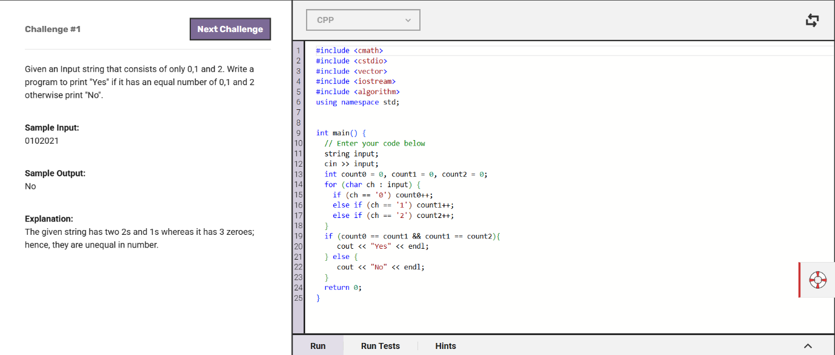

The program counts how many 0s, 1s, and 2s are in a given number string. If all three are equal in number, it prints Yes, otherwise, it prints No.

